Experiment No 6

6A

Aim: Study of Unix advanced scripts

6A.1

Write a script using grep command to find number of lines in file.

Output:

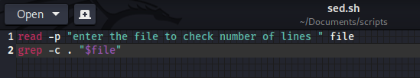

Fig 6a.1.1

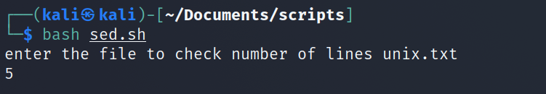

Fig 6a.1.2

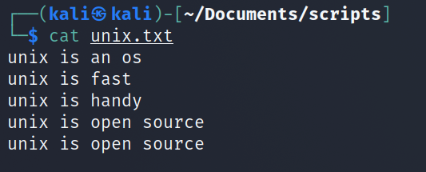

Fig 6a.1.3

6A.2

Write a script using egrep command to display list of specific type of files in the directory.

Output

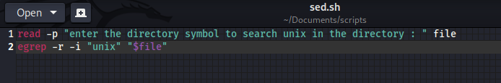

Fig.6a.2.1

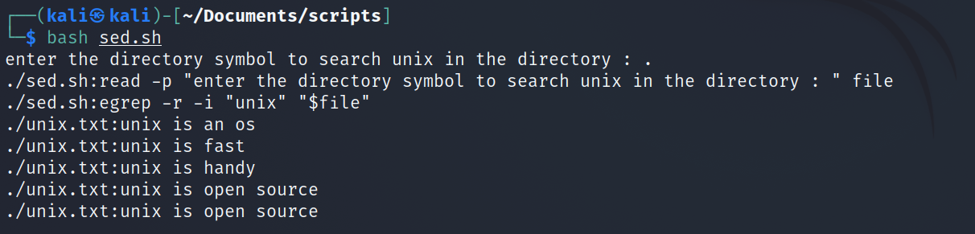

Fig 6a.2.2

6A.3

Write a script using sed command to replace all occurrences of particular word in given file.

Output

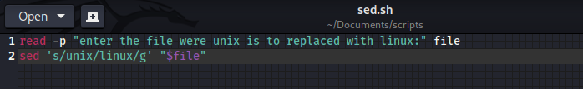

Fig 6a.3.1

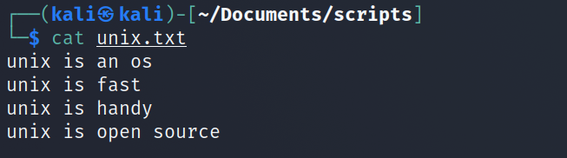

Fig 6a.3.2

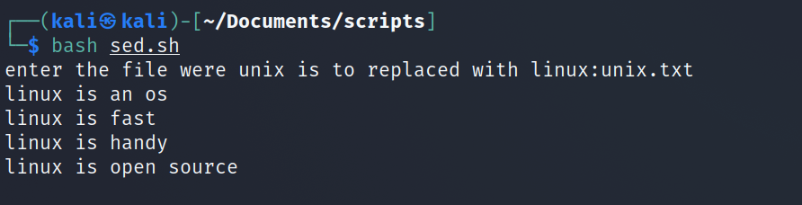

Fig 6a.3.3

6A.4

Write a script using select command to print duplicated lines in input

Output

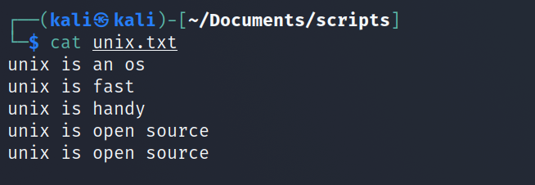

Fig 6a.4.1

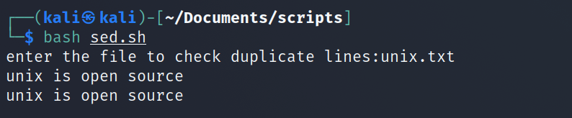

Fig 6a.4.2

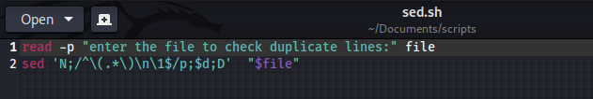

Fig 6a.4.3

Conclusion:

In the above experiment we used grep ,egrep sed commands in the scripts to do things as print lines in file, to print duplicate lines in file, to print specific file in the director ,to replace a certain word in a file.

Experiment No 6

6B

Aim : Execute the following script using awk /perl languages

6B.1

Write an awk script to print all odd numbers in a given range

Output

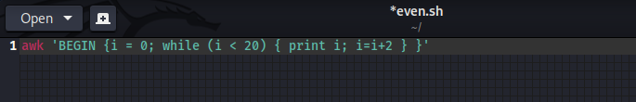

Fig 6b.1.1

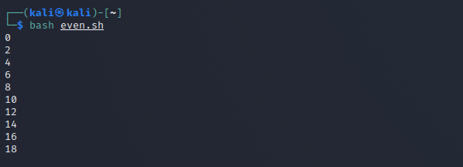

Fig 6b.1.2

6B.2

Write an awk script to develop a fibonacci series (take user input for number of terms)

Output

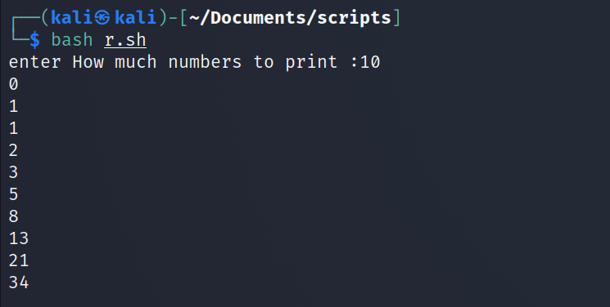

Fig 6b.2.1

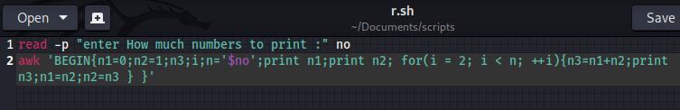

Fig 6b.2.2

6B.3

Write a perl script to sort element of an array

Output

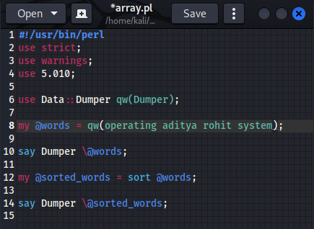

Fig 6b.3.1

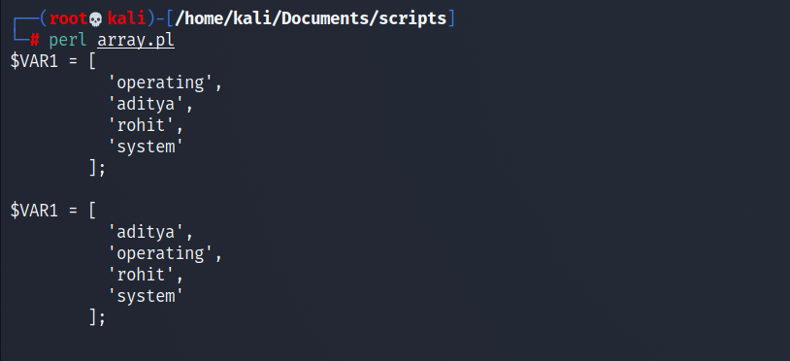

Fig 6b.3.2

6B.4

Write a perl script to check number is prime or not

Output

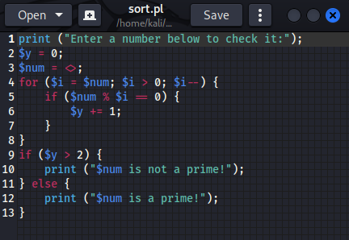

Fig 6b.4.1

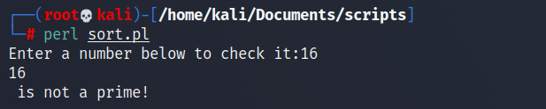

Fig 6b.4.2

Conclusion:

In the above we executed a number of scripts we using awk and pearl the scripts did the task such printing fibbonaci series printing even number printing if the number is prime or not and sorting an array.